

60.002 GROUP 1 (Sony’s Angels)

Amos Tan Pei Wei 1006640

Andrew Yu Ming Xin 1006879

Charmaine Hong Min Xuan 1007066

Fawziyah Binte Rosli 1007214

Michelle Halim 1007039

Mohamed Ammar Bin Mohamed Yusri 1006916

Table of Contents

1. Overview 3

2. Data Sources 3

3. Data Extraction 4

4. Data Processing 6

4.1. combined_df_transformed 6

4.1.1. Dimensionality reduction 6

4.1.2. Wordcloud visualization 7

4.1.3. Google Search Interest 8

4.1.4. N-grams 9

4.1.5. Topic Modelling 9

4.2. combined_df_og 10

4.2.1. Sentiment Analysis 10

4.2.2. RAG 10

4.2.3. OpenAI Party 13

5. Final Evaluation 15

6. Learning Outcomes 20

7. Appendix 21

**PREAMBLE**

Inspired by the sensational success of the Sonny Angel Popmart franchise, which has captivated global markets and emerged as the foremost sought-after collectible, we envision exactly the same achievement for our chosen product, the Sony WH-1000XM5[1] and as Sony’s Angels, we will serve as the driving force behind transforming this vision into reality. The Sony WH-1000XM5 will be known as XM5 hereafter.

1. Overview

The catalyst for choosing the XM5 for our project stems from the profound personal significance to the end user. Its extensive options for personalization and customization render it a meaningfully compelling subject for study, aimed at elevating the user experience to new heights. Given the XM5’s level of intimacy with the user, an abundance of extensive reviews is available, yielding valuable insights tol enrich our analysis and identify design opportunities. Additionally, as one of the latest additions to the Sony XM series, these headphones have garnered widespread acclaim[2] and are acknowledged as an exceptional value-for-money choice within their category. Their affordability and popularity further solidify them as a practical option for exploring design opportunities, as they represent a significant portion of the market share.

By immersing ourselves in the wealth of community-generated reviews, we aim to computationally uncover hidden opportunities to enhance comfort, functionality, and overall user satisfaction across various demographics and usage scenarios, bringing on an entirely new meaning to "built from the community, for the community".

1. Data Sources

Social media platforms offer a dynamic and multifaceted perspective compared to traditional sources of reviews. They serve as vibrant hubs for community engagement, where users freely share experiences, opinions, and recommendations. The real-time nature of social media fosters continuous feedback loops, enabling instant interactions between users. The wide array of social media platforms available caters to diverse demographics and user preferences, leading to a plethora of content styles and levels of engagement. The real-time nature of social media facilitates natural communication, enabling users to convey information effectively.

YouTube is visually-oriented, featuring long-form content such as detailed reviews, unboxing videos, and tutorials. It caters to tech enthusiasts, audiophiles, and consumers seeking comprehensive insights into headphone features, performance, and comparisons with competing products.

TikTok, known for short-form content, is ideal for sharing brief first-impressions and overviews of experiences. It is particularly popular among the younger generation.[3]

Reddit is text-centric, encouraging users to share thoughtfully written reviews and personal anecdotes. It also appeals to the younger generation aged 18 to 29 years old.[4]

Sony’s official website[5] provides a unique perspective on reviews. Users visiting these websites are inclined to leave feedback directly with the brand, leading to potentially higher proportions of detailed and genuine reviews. This direct connection fosters transparent communication between consumers and the company, influencing future product developments based on feedback received. Additionally, the official website advertises the full extent of the product, providing comprehensive information about specifications and functionalities. This enables reviews to also incorporate how well the product aligns with its advertised specifications and functionalities, which is invaluable for understanding how effectively the product meets user expectations and whether there are any discrepancies between marketing claims and real-world performance. Furthermore, the site serves as a hub for customer support and engagement, where users seek assistance with any issues they encounter. This interaction in the form of reviews can provide invaluable context for understanding common pain points or areas where users may require additional guidance or support.

E-commerce platforms play a significant role as a source of headphone reviews due to their accessibility and diverse user base.

Amazon, the largest e-commerce platform globally[6], boasts a vast user base and a wealth of diverse perspectives and experiences. Its robust refund policies contribute to the credibility of reviews available on the platform. Consumers are more likely to provide honest and candid feedback knowing that they have the option to return the product if it does not meet their expectations. This assurance fosters transparency and trust in the review ecosystem, enhancing the overall quality of the feedback provided.

Region-specific platforms like Amazon Singapore (SG) offer insights into local market preferences, while the US Global version, offering insights from diverse non-English speaking communities, enabling identification of region-specific nuances, trends or preferences crucial to consider for design opportunities

As the second-largest e-commerce platform[7], Walmart attracts users seeking value-for-money deals and competitive pricing. Reviews on Walmart may focus heavily on affordability and cost-effectiveness, providing insights into price sensitivity and perceived value propositions. Additionally, as the largest retailer in the United States[8], Walmart attracts reviews from customers who may not have made their purchases online, contributing to an even wider range of reviews.

Specializing in second-hand goods as the largest resale platform[9] , eBay's reviews reflect not only the product's original quality but also its longevity and durability over time. This provides valuable insights into long-term product performance and user satisfaction.

While considering other widely-known platforms, we encountered limitations. For instance, X's API is no longer free and its content is not easily accessible[10]. Meanwhile, Instagram falls short in terms of user engagement, with minimal comments and often consisting of emojis or focusing on the poster's appearance rather than the content or promoted product itself as evident from Figures 1 and 2.

1. Data Extraction

The Youtube API[11] has a quota limit of 10000 calls per day per API key, which reset 3pm SGT time. Searches cost 100 per call for a maximum of 50 videoIDs per page. CommentThreads (top-level comments) per videoID cost 1 per call for a maximum of 100 results per page. Comments to then extract all nested replies per CommentThread cost 1 per call for maximum 100 results per page. However, there was an API limitation where only these Comments extracted consisted of direct replies only to top-level comments, and not any replies to replies within top-level comments. Despite this limitation, 75922 comments were successfully extracted from 45967 CommentThreads from 585 videos in total using 5 API keys. These comments contained attributes like ‘comment_date’, ‘id’, ‘link’ and ‘like_count’, in addition to the ‘body’ content, as evident in Figure 3.

This open source TikTokCommentScraper tool[12] and its accompanying tutorial [13] were used to successfully extract 3312 comments from 11 videos in total. These comments contained attributes like ‘User @’, ‘Time’, ‘Likes’, and ‘Url’ in addition to the ‘Comment Text’ content, as evident in Figure 4. An issue encountered during this was an observation that many users are primarily motivated by seeking attention and achieving certain metrics, such as receiving "blue" comments, which may not relate to the video content but can garner significant likes and responses. Due to the brevity of TikTok videos, they may lack comprehensiveness, potentially omitting valuable information due to time constraints. This in combination with the anticipation of quick responses, causes commenters to frequently inquire about pricing and the like. To ensure content quality, the top comments on video posts were manually and swiftly reviewed to first ensure they align with the video's content and objectives, before scraping their data.

The Reddit PRAW (Python Reddit API Wrapper)[14] was used to successfully extract 13522 comments from 244 posts, of which 151 were text posts and therefore considered comments themselves) in total. These comments contained attributes like ‘comment_date’, ‘id’, ‘link’, and ‘like_count’ in addition to the ‘body’ content, as evident in Figure 5. A notable limitation of this API is that a hard limit of 1000 maximum posts is imposed and there is no known way to get around this limit.

The Sony official website required a custom Selenium extractor to be developed from scratch due to its unique structure, as detailed in the code accompanying this report. This extractor was used to load all reviews and extract their contents, resulting in the successful retrieval of 766 comments from the product landing page[15]. While these comments only included the 'body' content as evident in Figure 6, additional attributes like 'user', 'date', and 'review_rating' were available and could have been extracted simultaneously. Despite the product page displaying a total of 908 reviews, only 766 were extracted. This discrepancy may be attributed to some reviews being deleted without the site updating or loading errors during extraction. Nevertheless, capturing at least 85% of these reviews remains significant and valuable for analysis purposes.

For the Sony official website, as the site is quite specific, an extractor using Selenium was developed, and documented in the code accompanying this report. Selenium was used to first load all the reviews then extract its contents, successfully extracting 766 comments from the product landing page in total. [16] These comments only contained the ‘body’ content, as evident in Figure 6, but additional attributes like the ‘user’, ‘date’ and ‘review_rating’ could easily have been extracted at the same time. Although the product landing page displays a total of 908 reviews, only 766 were extracted, which could be due to some being deleted without updating values or loading errors. As at least 85% of these reviews were captured, it is still significant and helpful.

The Amazon Scraping Chrome Extension[17] was found to be outdated and incompatible with recent updates made to Amazon's pages. Following guidance provided in a helpful reference[18], the source code of the extension was modified to adjust JavaScript variables and successfully extract 268 unique comments from 5 SG product listings and the main US product listing - 6 product listings in total. These comments contained attributes like ‘reviewerName’, ‘stars’, ‘reviewLink’, ‘reviewTitle’ and ‘reviewMeta’ in addition to the ‘body’ content, as evident in Figure 7. An issue encountered during this was the unexpected discovery of multiple products instead of a single product with different color options. These products turned out to be packages or bundles containing the main product, XM5. To address this issue, we decided to limit our focus to the first 10 products with more than 100 reviews each. This decision proved beneficial, as later products began to lose relevance, and their reviews would not have significantly contributed to the analysis. The listings selected using this method are illustrated in Figure 8.

To bypass Walmart’s bot detection, an extractor using SeleniumBase (an undetectable version of Selenium) was developed, and documented in the code accompanying this report. 355 unique and non-empty comments were extracted from 5 product listings in total. These comments contained attributes like ‘reviewerName’, ‘stars’, ‘reviewLink’, ‘reviewTitle’ and ‘reviewDate’ in addition to the ‘body’ content, as evident in Figure 9.

For eBay, a similar extractor using SeleniumBase was developed. 70 comments were extracted from 1 product listing in total. These comments contained attributes like ‘reviewerName’, ‘stars’, ‘reviewLink’, ‘reviewTitle’ and ‘reviewDate’ in addition to the ‘body’ content, as evident in Figure 10.

While only the body content of reviews was utilized for analysis in this project, the scope can certainly be broadened to include significant metrics such as 'like_count' or 'stars', which indicate the popularity and overall sentiment of the reviews with regard to the XM5. A review that is more popular or well-received can signify a higher level of resonance and relevance of opinion among consumers. Consequently, such reviews may be given greater weight in the analysis, indicating a more urgent need to pursue them as potential design opportunities. This prioritization ensures that design efforts are aligned with the preferences and sentiments of a larger segment of the target audience, ultimately leading to more impactful product enhancements.

1. Data Processing

In total, 91 858 unique comments were successfully extracted for further processing, as evident in Figure 11. As part of data augmentation, these comments underwent initial cleaning, primarily involving the removal of URLs to reduce comment lengths, via the cleantext Python library[19]. Subsequently, the language of each original comment was identified via the googletrans Python library[20] and then translated to English for universal understanding via the deep_translator Python library[21]. The resulting dataset is as illustrated in Figure 12.

After the translation process, the data was divided into two separate sets. The first set, named 'combined_df_og', remained as the original dataset up to this point. This set enables the conduct of analyses that pertain to the context of the text, such as Sentiment Analysis and Retrieval Augmented Generation (RAG). The second set, named 'combined_df_transformed', underwent dimensionality reduction through further cleaning and reducing the vocabulary size. This reduction was performed to facilitate tasks such as Wordcloud visualizations, n-grams, and topic modeling.

* 1. combined_df_transformed
     1. Dimensionality reduction

Initially, we aimed to rectify typographical errors to maintain the intended meaning of the text. However, this approach was ultimately abandoned due to its tendency to introduce additional errors. Notably, it often altered nouns such as "Bose" (a competing headphone brand) to dictionary words like "bosses" or "bosy," thereby distorting their original meanings. An alternative method involved using Part Of Speech (POS) tagging to avoid correcting nouns. Nevertheless, correcting misspellings in consideration of the entire context is more effective. Moreover, splitting the text before and after a noun to apply these corrections would significantly increase computational time and resource consumption. Therefore, the steps for dimensionality reductions included expanding standard contractions to their full forms - "don't" became "do not", removing stopwords (commonly occurring extraneous elements like "the,", punctuation, emoji) and lemmatizing the words to reduce them to their base or dictionary form.

Since these comments originate from social media and ecommerce platforms, they may encompass feedback on various aspects such as the content creator, shipping process, or staff, rather than solely focusing on the product. Consequently, a HuggingFace mDeBERTa zero-shot classification model[22] was employed to augment the density of comments pertinent to the "product" class, to refine our analysis to exclusively address product-related concerns, enabling us to identify potential design opportunities. Through this, the dataset was narrowed down to 52718 comments, 57.4% of the original dataset, evident in Figure 13. A drawback of this approach is that certain comments may reference both the product and other elements within the same comment, potentially leading to their omission if they are not primarily product-related, depending on the functioning of the classifier.

* + 1. Wordcloud visualization

Using the Wordcloud Python library[23], a visualization of the top 100 words was generated, as evident in Figure 14. To further enhance the relevance of the data, we filtered out numerous nonessential verbs such as "feel," "love," and "talk," which individually don't convey substantial meaning related to the XM5. Instead, we focused on extracting nouns preliminarily pertaining to device features and models, along with adjectives that could potentially describe the headphones. This process was facilitated through Part of Speech tagging. Thereafter, 14 features in order of significance of concern (based on font size in the visualization) were successfully managed, as evident in Figure 15.

|  |  |
| --- | --- |
| **Features** | **Models** |
| Sound Quality | xm4 |
| anc (Active Noise Cancellation) / noise cancellation / noise reduction | xm3 |
| bass | Bose (qc45) |
| design | sennheiser momentum |
| comfort | Airpods Max |
| big |  |
| ear |  |
| wire |  |
| bluetooth |  |
| call |  |
| microphone |  |
| ldac |  |
| eq |  |
| price: cheap / expensive / worth |  |

* + 1. Google Search Interest

Google Search Interest was used to supplement and cross-reference with our WordCloud Visualization. Figure 17 illustrates the search terms, that co-occurred with the XM5 from the period of its release on 12 May 2022 to the present day, in order of relative search interests. We gained affirmation that the noise-canceling feature was indeed the most significant, evident from the numerous mentions in rows 7, 19 and 23, while brands-wise, the top competing headphones were indeed Sony's own previous models XM4 and XM3, mentioned in rows 5 and 18 respectively in addition to specifically the Apple AirPods Max, Bose QuietComfort and Sennheiser Momentum, mentioned in rows 12, 16 and 22 respectively.

**“Design is all about the target audience”**

We expanded our approach by delving into the Google Search Interests segmented by geographical regions. This enabled us to identify the target audience for Sony's headphones. By understanding the preferences and inclinations of different regions, we can tailor our products to meet the specific needs and desires of our target demographic. Our objective is twofold: to maintain customer satisfaction by catering to positive feedback and to enhance offerings by addressing any areas of dissatisfaction, by concentrating efforts on specific regions. This iterative process allows continuous refinement and optimization of Sony’s products to better serve customers and stay ahead, regardless of their current position in the competitive market. From Figure 18, the Search Interest is sorted in descending order, with Hong Kong being the highest, followed by Singapore, then Norway and so on.

Using the language of the original comment calculated earlier, the top 20 language frequencies of comments were plotted, as depicted in Figure 19. Languages like English and Spanish were excluded, given their status as the most widely spoken languages globally[24], making it challenging to pinpoint a specific region as the target audience. However, despite Mandarin (zh-CN) being another top spoken language, it was surprising to note its significantly lower numbers compared to English and Spanish. This observation prompted its inclusion for further analysis. Interestingly, the Google Search Interest segmented by geographical regions, as mentioned earlier, indicated that Hong Kong held the highest interest. This finding could potentially elucidate this phenomenon, suggesting that customers in Hong Kong could be singled out as the target audience for Mandarin instead. Consequently, further investigation focused on the top 3 frequencies (Russian, Korean, Japanese) and bottom 3 frequencies (Czech, Polish, zh-CN) to explore potential design opportunities tailored to these specific target audiences.

* + 1. N-grams

2-grams to 5-grams were selected to analyze the co-occurrence of phrases in relation to their frequencies. The decision to use 'n' where n = 2 and n = 5 was made to provide sufficient context compared to single words (1-grams). The output was manually inspected to ensure thoroughness and supplement our comprehension of the dataset. From this analysis, the following information on features, usage, behavior, and models was extracted.

|  |  |  |
| --- | --- | --- |
| **Features** | **Usage & Behaviour** | **Models** |
| Battery life | Video | Bose QC45 |
| Call quality | Call | Bose 700 |
| Ear cup | Watch movie | (Bowers & Wilkins) PX7 S2 |
| Ear pad | Zoom | Sennheiser Momentum 4 |
| Transparency mode | Cabin Pressure | Momentum 3 |
| Custom EQ |  | Mark 5 (another name for XM5) |
| Sound signature |  | Focal Bathys |
| LDAC codec |  | Soundcore Space Q45 |
| Frequency response |  | Soundcore Life Q35 |
| Hurt ear |  | Galaxy Bud 2 Pro |
| Ear sweat |  | (Bang & Olufsen) BO H95 |
| Small ear |  | Technics A800 |
|  |  | Stax Spirit S3 |
|  |  | Shure Aonic 50 |
|  |  | Audeze Maxwell |

The relevance remained consistent up to 10,000 rows. Beyond this threshold, repetitions of word subsets or supersets were observed, which proved to be less valuable. This observation of "10,000" will inform the setting for the max_features parameter in the topic modeling process in the next step.

* + 1. Topic Modelling

Latent Dirichlet Allocation (LDA) is an algorithm which discovers latent topics within a collection of documents by analyzing word patterns that occur with each other. These topics are then clustered together according to maximum variation across 2 principal components. The vectorizer considers the first 10,000 rows, ignores terms occurring in at most 2 comments, and considers only 2-grams to 5-grams. Through Randomized Search Cross Validation, the topic model was optimized and the data was modeled by 4 topics. However, the topics lacked coherence as evident in Figure 20, suggesting irrelevant data for underlying inferences. Furthermore, there's considerable repetition, often reiterating information we already knew previously. To address these issues, we iterated and transitioned to using only 3-grams, with the objective of incorporating more relevant contextual information. This proved to be considerably better as we were able to clearly delineate topic boundaries, as evident in Figure 21. As such, manually labeling these topics proved an easy task, with topic 1 clearly being gibberish/spam comments, while topic 2 highlighted an environmental noise issue with the Bose QC Ultra or the XM5 or Airpods Max, topic 3 placing heavy emphasis on sound quality, regarding (Bowers & Wilkins) PX7 S2 and Airpods Max, and topic 4 being solely about the different brands. Figures 22 to 25 illustrate the likelihood of 30 comments being assigned to these topics respectively, which helped to further solidify our topic labels. While topic modeling revealed several areas for further investigation, we ultimately do not find it particularly useful overall. This is because the interpretation of the topics and the underlying issues themselves are left to us and human biases and preconceptions can play a part, thus involving a significant level of subjectivity.

A possible area of improvement in this part would be to input these words, delineated by topics, into a well-trained LLM such as the OpenAI GPT 4, which would automatically generate nigh correct topic labels, as opposed to human generated ones.

* 1. combined_df_og
     1. Sentiment Analysis

A HuggingFace RoBERTa sentiment classification model[25] was employed to analyze sentiments of comments containing the XM5. Sentiments as evident in Figure 26 were overwhelmingly positive, but the presence of negative sentiments suggests potential design opportunities.

* + 1. RAG

Using LangChain to create a large-scale language model by stitching together multiple smaller models, each model in the chain specialized in understanding a chunk of comments. These comments are then encoded and indexed into mathematical representations of words, phrases, or documents in a continuous vector space for efficient retrieval. OpenAI’s GPT serves as the generative component, responsible for generating coherent and contextually relevant responses based on the retrieved information. By leveraging the context provided by the retrieved passages, GPT can generate more accurate and informative responses compared to standalone GPT.

**"Design opportunities stem from the many different ways people can and will use a product"**

|  |
| --- |
| What is the same category of product as {PRODUCT[26]}? Who, what, when, where, why and how do consumers do with products in this category? Output your answer to this second question separated by a newline, strictly inside a Python dictionary with keys: 'who', 'what', 'when', 'where', 'why', 'how' |

This prompt enabled us to gather the consumer behavioral patterns and use cases, which were critical areas to optimize, as they are the main areas to bring value in.

The results suggest the headphones should be optimized for

* Who: Students, professionals, travelers, or any individuals who value high-quality sound and noise cancellation
* What: Music, podcasts, movies, calls and video conferences
* When:Studying, working, traveling, or relaxing
* Where: At home, in the office, commute or public places
* Why: Noise-canceling feature, sound quality, comfort, and additional features like ambient mode
* How: Connect these headphones to their devices (like smartphones, laptops, tablets) via Bluetooth

|  |
| --- |
| Provide a detailed comparison between {PRODUCT} and its competitors concerning the {feature} aspect, utilizing only the provided data. Do not always rank {PRODUCT} first unless it is really true based on the data. Give the answer in the exact form of "{feature}": Python dictionary with the key "ranking", where the values are the ranking listed in a Python list (with the highest-ranking product being the first in the list), and another key "details", with the details in a Python list (if any, do not simply describe the ranking sequence) highlighting the exact specific details that users specifically want. If no specific details are available, just give an empty list |

A benchmarking (rank and details) is obtained using all the features discovered earlier and this prompt.

|  |
| --- |
| {  "ranking": ["Sony WH-1000XM5", "Sony WH-1000XM4", "Bose 700", "Sennheiser Momentum 3", "AirPods Max"],  "details": [  "Sony WH-1000XM5 and Sony WH-1000XM4 both support sbc, aac, and ldac codecs, giving them an advantage over competitors like Bose 700, which only support sbc and aac.",  "AirPods Max also support sbc, aac, and alac codecs, but do not support ldac, which is a significant advantage for Sony headphones in terms of audio quality.",  "Sennheiser Momentum 3 supports sbc, aac, and aptx codecs, but lacks ldac support, putting it behind Sony headphones in terms of codec compatibility."  ]  } |

An example response as above details reasons even if the XM5 ranks the highest. This provides extremely valuable insights into the gap between itself and the closest competitor.

|  |
| --- |
| For the {PRODUCT}, what are some key positive points and key negative points? Give maximum 5. Output your response in a python dictionary with keys 'positive' and 'negative', with values as a Python list |

Data-driven key positive and negative points were obtained from the top 3 and bottom 3 frequencies by language and this prompt.

|  |
| --- |
| japanese: {  'positive': ['Excellent call quality with noise cancellation', 'Lightweight design', 'Good environmental sound sensing feature', 'Convenient to use', 'Good sound quality'],  'negative': ['Strong bass might not suit everyone', 'Muffled sound at times', 'No inward folding mechanism for portability']  } |

An example response as above delves into identifying the positive components to retain, while exploring the potential for modifying or making adjustable the negative components. Additionally, it suggests considering exports to Japan for quality checks regarding sound muffling, particularly if more comments specifically mention this issue.

|  |
| --- |
| Based on the previous key points, how do you advise to tailor the product specifically for them, in terms of design specifications? Be very precise and give specific numbers and methods. Give maximum 5. It is best if your suggestions are firmly supported by the data provided. Output your response in a python dictionary with key 'negative', with values as a Python list in double quotes |

Data-driven design specifications suggestions for negative key points were obtained from the top 3 and bottom 3 frequencies by language and this prompt.

|  |
| --- |
| japanese: {  "negative": [  "Incorporate a more adjustable EQ system to allow for better customization of sound profiles based on individual preferences",  "Consider implementing a foldable design mechanism to enhance portability and storage convenience",  "Focus on refining the bass response to be more balanced and less overpowering for a wider range of users"  ]  } |

An example response as above pinpoints which part of the system to consider modifications, and the respective reasons, which would be sufficient for Sony’s technical employees to improve on or rectify any potential issues.

Overall, the XM5 seems to be a market leader and receives widespread praise for many of its top-notch features. Nevertheless, there is room for improvement in certain aspects, prompting a manual inspection. GPT's assistance was limited in this regard, as it aggregated all comments without discerning specific nuances, resulting in overly generalized statements.

For instance, regarding the comfort, Figure 27 references a complaint regarding multiple aspects of the cushioning and the inability of the black color used to conceal fingerprints. Similarly, regarding the design, Figure 28 references another complaint regarding the tactile controls, difficult cleaning processes and discomfort on the ear lobes. Figure 29’s takeaway is that Sony should improve their wired compatibility and be careful of not discontinuing it, as users still rely greatly on this feature. Figure 30 compliments Sony’s microphone, which Sony should take note to maintain the quality of. Figure 31 represents the potential to capture Apple’s market share (and push the competition out) by innovating a feature to not require the LDAC codec for quality sounds as the XM5’s currently have it. Figure 32 suggests reducing reliance on an external app and simply making the XM5 tuned well or perfectly from the get-go. However, it also highlights a point that the XM5 offers personalized and custom tuning albeit from an external app. Figure 33 suggests improvements to the XM5 to improve its battery life from a mere 27 hours to 62 hours, support both aptx and aptx hd standards, lower latency to a quarter of the current and support USB connection, comparing to the Sennheiser. These are all pain points that could be considered as design opportunities to design a much more user-friendly and user-validated product.

Figures 34 to 39 illustrate the original comments from the top 3 and bottom 3 language frequencies that contributed to GPT’s analysis. Specifically, Figure 36 demonstrates the perception of the foldable design in the previous XM4 model being considered a critical feature. Similarly, a Reddit poll on the issue indicated that almost 50% of respondents were indeed not satisfied with the removal of this feature in the XM5. Considering this as a design opportunity, it could be possible to manufacture 2 different versions of the XM5, to appeal to different types of preferences. Figure 39 also highlights potential concerns regarding creaking over time, indicating the necessity of conducting stress tests on the product over an extended period, especially if such tests have not been conducted previously.

* + 1. OpenAI Party

|  |
| --- |
| Based on the features data only, output exactly what is expected of {PRODUCT} to get ahead of competition, quantitatively and detailedly |

Using this prompt in OpenAI GPT 4 generated a comprehensive list of suggestions to fix the respective issues.

|  |
| --- |
| What is this product and what are the critical parts of this product relevant to redesigning these features: {design_ops}? Be detailed and quantitative for all your response. |

Figures 40 to 43 illustrate the exploded diagrams of the XM5[27], which were input into OpenAI GPT Vision with this prompt in combination with the response to the prompt above and the specifications of the current XM5 model to generate the ideal specifications for a new model

**“A significant part of a design opportunity surrounding any product lies in how it is marketed, and branded, how it should stand out from everything else”**

|  |
| --- |
| From an image of a product or users using that product, give me all the detailed ways to analyze the image from an artistic point of view |

Inserting this prompt into OpenAI GPT 4 generates a comprehensive list of artistic analysis methods, using its current domain knowledge.

|  |
| --- |
| You are a professional image analyzer helping me create the perfect and optimized image for my product. Analyze these images using the art_analysis techniques, listing different strategies as an overall analysis of all the images. Do not output analysis for each individual image. Be extremely detailed and critical in your overall analysis. |

Using this prompt in OpenAI GPT 4 Vision, accompanied by images of product and usage of the product from competing brands, a comprehensive list of various strategies is obtained.

|  |
| --- |
| Create an image of {PRODUCT}, using a permutation of different techniques previously, do not reuse if you have used it once |

This prompt in OpenAI Dall-E helped uncover viable permutations from competing brands, for fresh and innovative designs to attract consumers attracted to certain design elements from competing brands, such as Figures 44 to 48 (image of product) and Figures 49 to 53 (image of product usage)

4.2.4 Dall-E Party

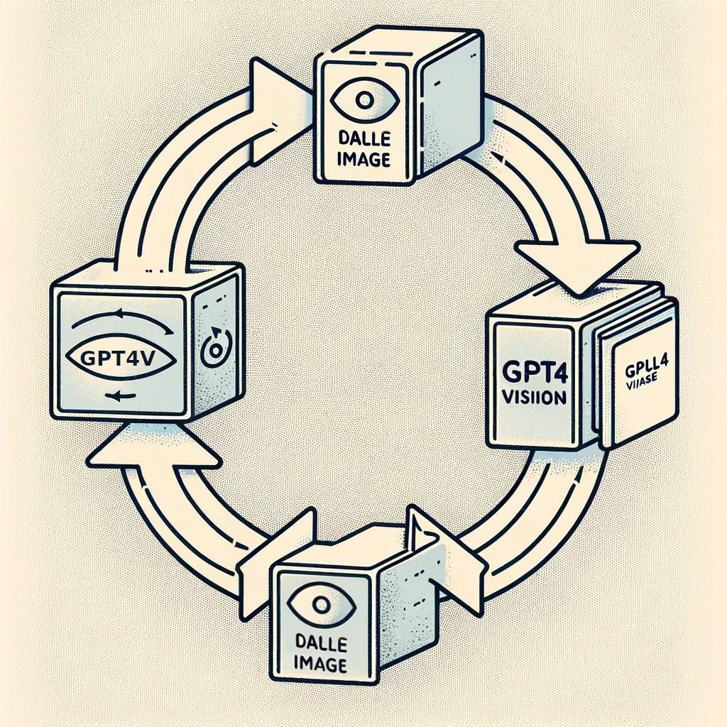  
**Dall-E party[28] inspired by Translation Party[29] (back in 2009)**

**"Iteration is at the heart of design"**

The Dall-E Party comprises a cycle wherein a prompt is fed into OpenAI GPT Vision to create a prompt, which is then used as input for OpenAI Dall-E to produce an image. This image is subsequently fed back into OpenAI GPT Vision, repeating the process with the objective of iteratively refining the design and ultimately generating the optimal outcome.

|  |
| --- |
| Write a prompt for an AI to make this image accurately. Make sure you emphasize the model should look photorealistic, as real people taken with Sigma 85mm f/1.4. Just return the prompt, don't say anything else. Make everything more visually appealing and the focus should be on the product to attract more customers |

A reference image was selected via vote, among the group members. Using Figure 54 as the reference image in addition to this prompt with the intensifier to enhance visual appeal and attract more customers, Figures 55 to 59 were generated iteratively. Figure 56 was selected as the most visually appealing while Figure 57 came in close second, via a matrix of votes.

1. Final Evaluation

Referencing the current XM5’s images of product (Figure 60 to 61) and of product usage (Figures 62 to 66), our final recommendation for (what the Sony WH-1000XM6 expected to come out Spring 2024 should be) and design opportunities are as detailed:

The new product should be optimized for

* Who: Students, professionals, travelers, or any individuals who value high-quality sound and noise cancellation
* What: Music, podcasts, movies, calls and video conferences
* When: Studying, working, traveling, or relaxing
* Where: At home, in the office, commute or public places
* Why: Noise-canceling feature, sound quality, comfort, and additional features like ambient mode
* How: Connect these headphones to their devices (like smartphones, laptops, tablets) via Bluetooth



**Image of product**

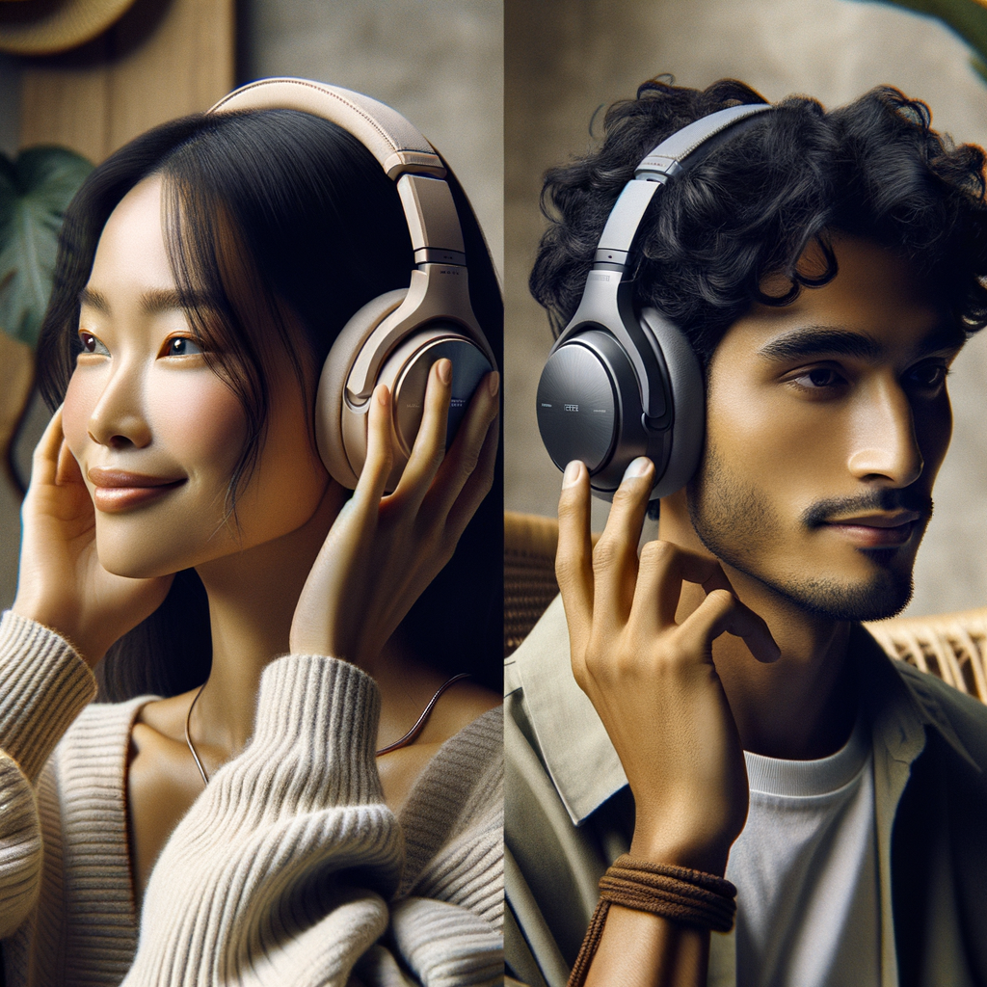



**Images of product usage**

|  |  |  |
| --- | --- | --- |
| General Features | Weight | **Approx. 220g - 230g** (lighter materials used for Russian market) |
| Volume Control | Touch Sensor |
| Headphone Type | Closed, dynamic |
| Input(s) | Stereo Mini Jack, **High-quality DACs and audiophile-grade cable for high-end version** |
| DSEE Extreme | Yes, **with enhanced DSP algorithms for improved ANC** |
| Cord Length | approx. 1.2m |
| Ambient Sound Mode | Yes, **with enhanced signal processing and additional external microphones for accurate ambient sound capture** |
| Magnet | Neodymium |
| Impedance (Ohm) | 48 ohm (1kHz) (when connecting via the headphone cable with the unit turned on), 16 ohm (1kHz) (when connecting via the headphone cable with the unit turned off) |
| Plug | Gold-plated L-shaped stereo mini plug |
| Passive Operation | Yes |
| Driver Unit | **35mm - 40mm** (increased size for Russian market) |
| Wearing Style | Over Ear, **with adjustable headband tension system and pivot points on ear cups for comfort** |
| Materials and Design | External Housing | **High-grade plastics or metals with matte or textured finish to reduce fingerprint visibility** |
| Ear Pads | **Memory foam or similar premium material** |
| Frequency Response | Bluetooth® Communication | 20Hz-20,000Hz (44.1kHz sampling), 20Hz-40,000Hz (LDAC 96kHz sampling 990kbps) |
| Active Operation | 4 Hz - 40,000 Hz |
| Sensitivities (dB/mW) | | 102dB (1kHz) / mW (when connecting via the headphone cable with the unit turned on) |
| 100dB / mW (1kHz) (when connecting via the headphone cable with the unit turned off) |
| Battery | Charge Time | Approx. 3.5 hrs |
| Charge Method | USB |
| Life (Continuous Music Playback Time) | Max. 35 hrs (NC ON), Max. 45 hrs (NC OFF) **(increased battery capacity)** |
| Life (Continuous Communication Time) | Max. 28 hrs (NC ON), Max. 36 hrs (NC OFF) **(increased battery capacity)** |
| Bluetooth® Specification | Supported Audio Format(s) | SBC, AAC, LDAC, additional high-resolution codecs |
| Frequency Range | 2.4GHz band (2.4000GHz-2.4835GHz) |
| Version | Bluetooth Specification Version5.2 |
| Supported Content Protection | SCMS-T |
| Effective Range | 10m |
| Profile | A2DP, AVRCP, HFP, HSP |
| Noise Canceling | Atmospheric Pressure Optimizing | Yes |
| Personal NC Optimizer | Auto NC Optimizer |
| Quick Attention | Yes |
| Ambient Sound Mode | Yes, **with enhanced signal processing and additional external microphones for accurate ambient sound capture** |
| **Additional Features** | **Custom EQ** | **On-board adjustment capabilities without sole reliance on external apps** |
| **Foldable Design** | **Inward folding mechanism for Japanese and Czech markets** |
| **Durability** | **More robust materials and stricter quality control measures for Korean market** |
| **Adjustable Bass Levels** | **Enhancement on the DSP and equalizer settings for Japanese and Chinese markets** |
| **Transparency Mode** | **Enhanced with better signal processing and additional external microphones for accurate ambient sound capture.** |
| **Enhancements from customer feedback** | | **Cleaning the ear cushions is now easier** |
| **Enhanced compatibility with Apple devices (LDAC Codec not mandatory)** |
| **Added USB connectivity support** |

**Ideal specifications with modifications in bold**

Additionally, an instruction manual to assist in modifying the product to fit the new specifications, with reference to exploded diagrams in Figures 40 to 43.

|  |  |  |
| --- | --- | --- |
| For design and materials | | Aesthetics can be addressed through the shape and finish of the external housing (Ref. No. 151/153) and ear pads (Ref. No. 1/2) |
| For overall comfort | | The padding materials (shown as cushion heat conduction parts Ref. No. 103/104) could be made from memory foam or a similar premium, comfortable material. |
| The ear cups (Ref. No. 151/153) design could include pivot points or an adjustable angle mechanism |
| For maintaining high-quality Bluetooth and call quality | | Choose a Bluetooth chipset with the latest standards and high-fidelity transmission capabilities (usually found on the main board Ref. No. 152). |
| For codec support | | The main board's firmware (Ref. No. 152) should continue to support various codecs and consider integrating additional high-resolution codecs alongside LDAC. |
| For the custom EQ within apps | | The DSP software on the main board (Ref. No. 152) should allow for on-board adjustment capabilities without sole reliance on external apps. |
| For battery life improvement | | Increase the capacity of the battery (Ref. No. BAT1) while maintaining its size or switch to a more energy-dense chemistry, ensuring it fits within the allotted housing compartment. |
| Region-specific considerations | Russian Market | Increase driver size: This might require enlarging the housing (Ref. No. 151/153), which could impact comfort and design, so balance these factors accordingly. |
| Korean Market | Durability improvements can be addressed by selecting more robust materials and by implementing stricter quality control measures or stress tests to all critical components such as screws (Ref. No. 52) and plastic housings (Ref. No. 151/153). |
| Japanese Market | Adjustable bass levels can be an enhancement on the DSP and equalizer settings, which are programmable on the main board (Ref. No. 152). |

1. Learning Outcomes

Design philosophies are dispersed and highlighted in bold to remind others attempting the same or a similar project of the foundations of design and the various factors to consider when exploring design opportunities beyond just the product itself. It is essential to remain vigilant for any potential aspects that may impact the design process and may not immediately appear as design opportunities.

We hope the tools provided, especially those not readily available or updated online and the accompanying insights into their limitations will also be able to assist anyone undertaking a similar project.

Despite containing fewer than 100,000 comments, our original dataset still presented significant challenges. Therefore, employing efficient data-handling libraries like Polars, rather than relying solely on the traditional Pandas Python library, proved beneficial. While perhaps not imperative for datasets of our size, it is also advisable to consider utilizing efficient data types and downsizing where feasible. For instance, converting numeric columns from int64 to unint16 and strings to categorical if they possess repeating finite values. Furthermore, opting for efficient and lightweight file formats such as Parquet over CSVs can greatly reduce storage overhead, albeit with a tradeoff in file-reading conveniences.

Utilizing split terminals for parallel processing significantly accelerated our workflow. Running multiple terminals simultaneously allowed us to complete tasks in a fraction of the time, with the option to concatenate datasets afterward. This approach also facilitates error identification and resolution earlier in the process, mitigating the risk of losing all progress if an error occurs during sequential processing.

Prompt engineering was also a critical aspect of our methodology. Ensuring prompts are clear, explicit, and reiterating information aids in obtaining an equivalently clear output. The ability to also prompt for and obtain Python variables as output, was extremely helpful, as they could then be seamlessly integrated into subsequent steps of the process.

1. Appendix

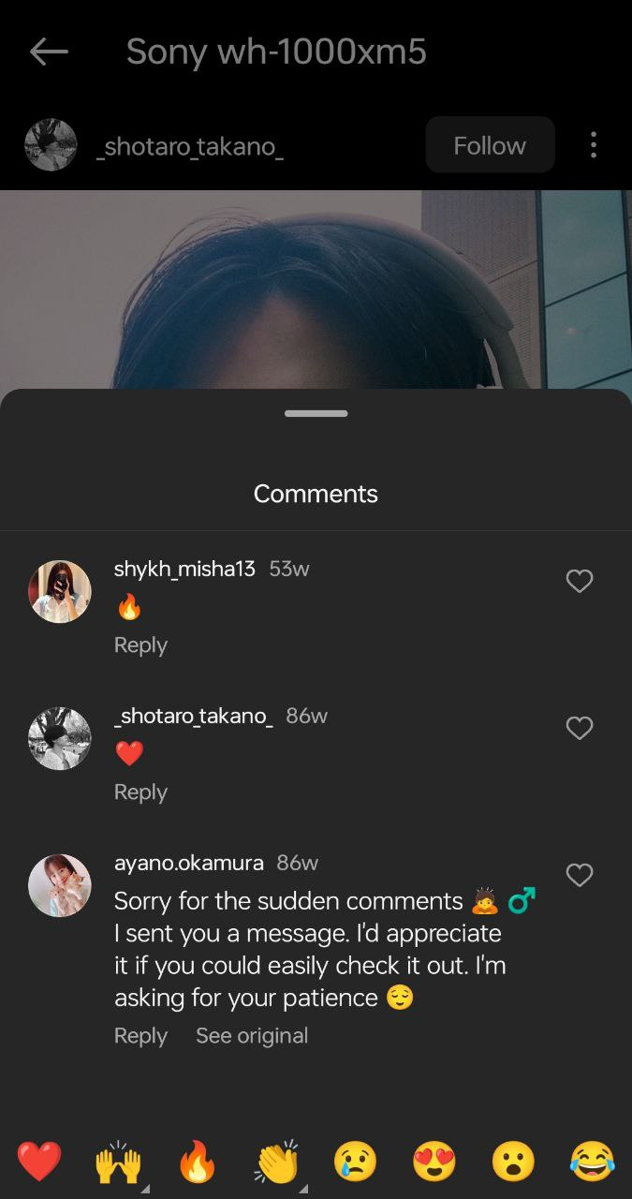

**Figure 1**

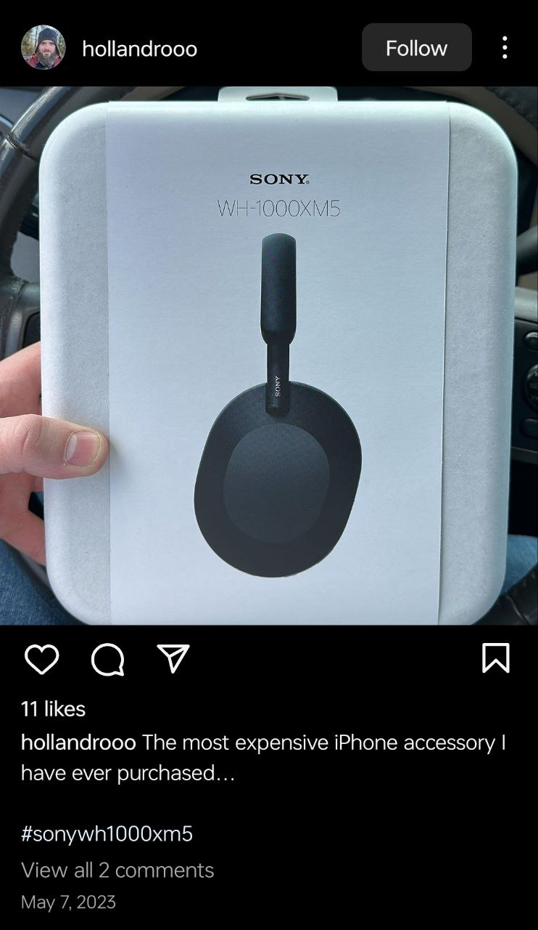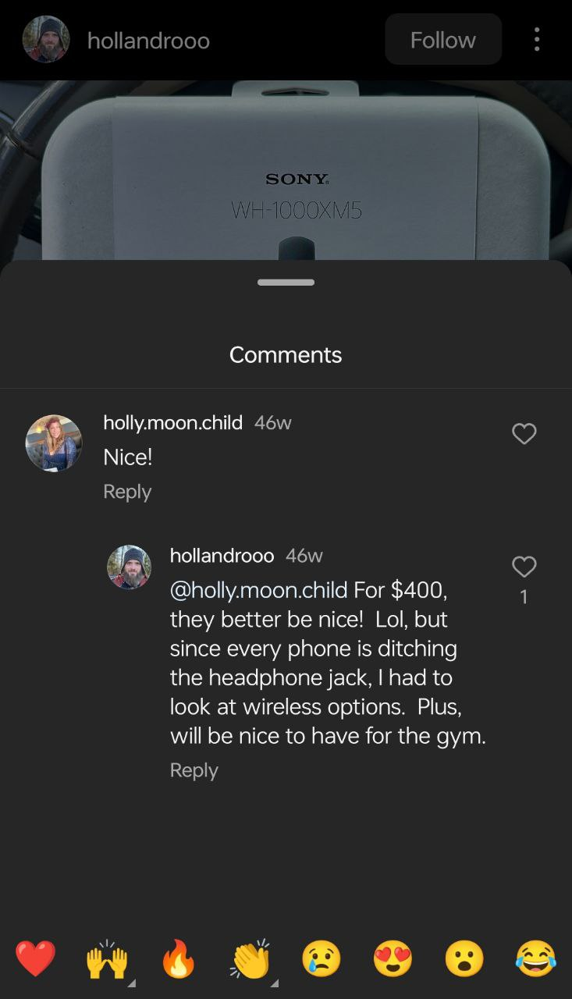

**Figure 2**

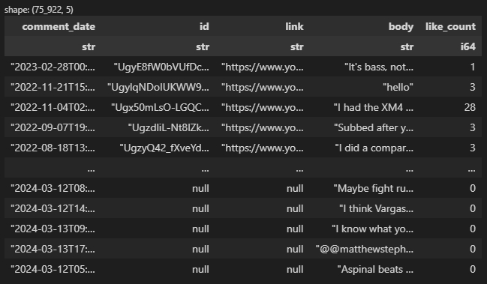

**Figure 3: Youtube dataset**

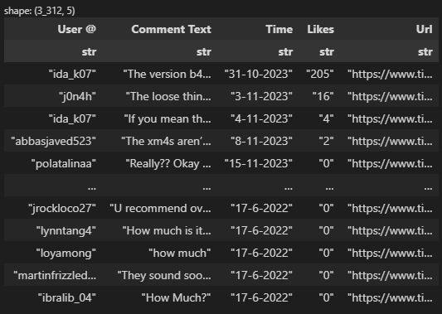

**Figure 4: TikTok dataset**

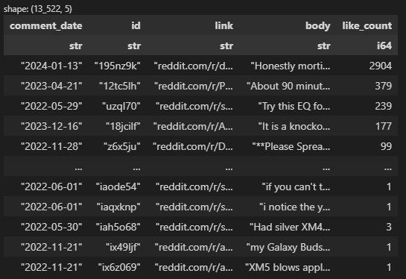

**Figure 5: Reddit dataset**

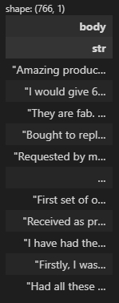

**Figure 6: Sony official website dataset**

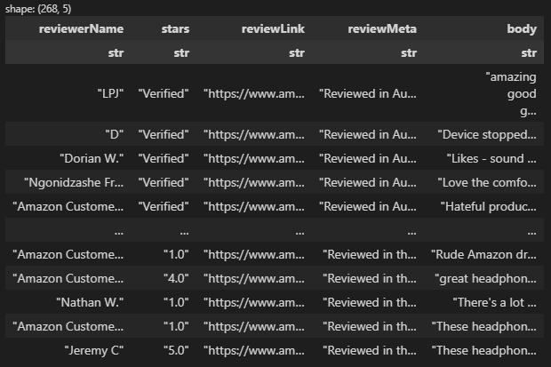

**Figure 7: Amazon dataset**

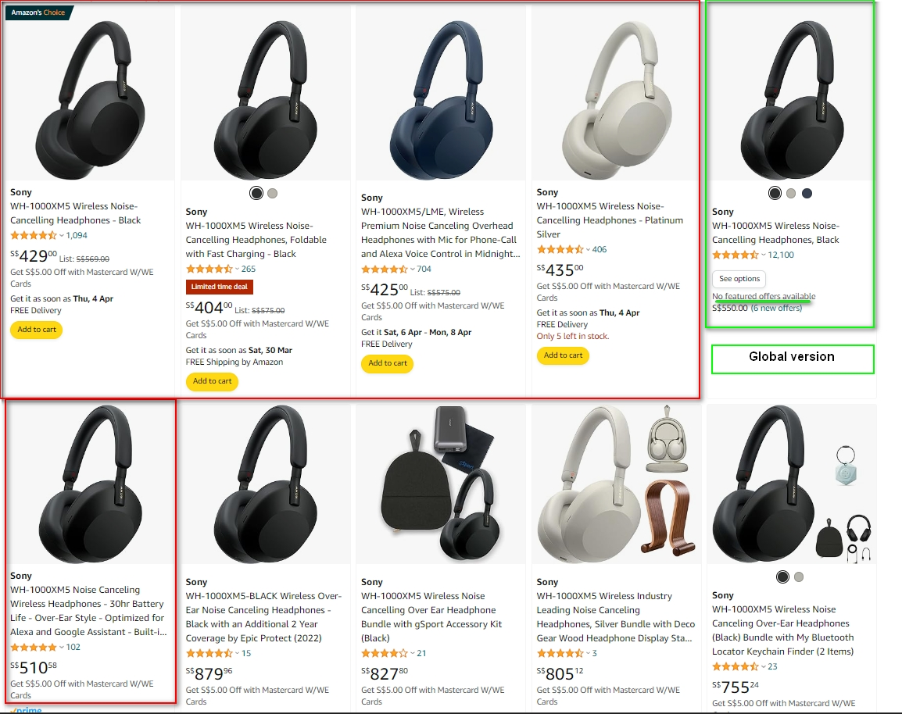

**Figure 8: Selected product listings from Amazon**

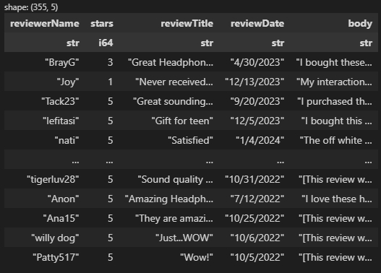

**Figure 9: Walmart dataset**

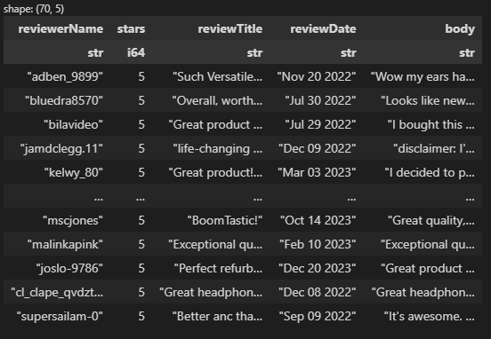

**Figure 10: eBay dataset**

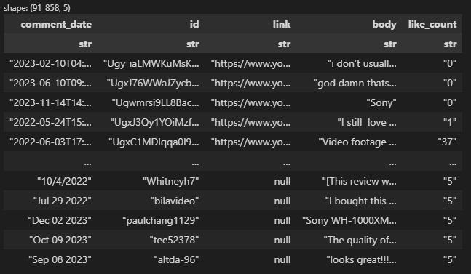

**Figure 11: Combined dataset**

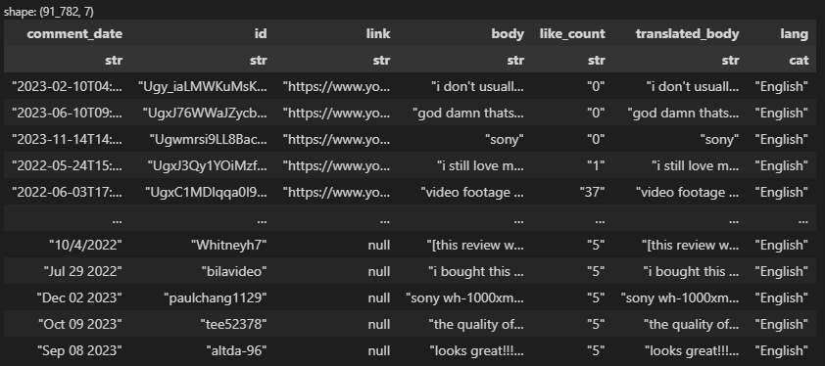

**Figure 12: Combined processed dataset**

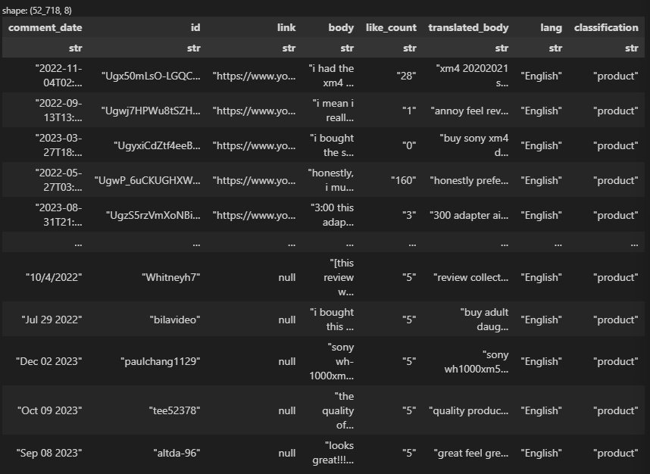

**Figure 13: combined_df_transformed after zero-shot classification and filtering**

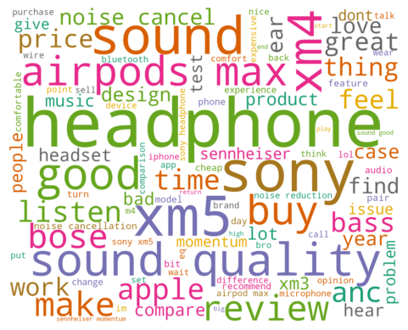

**Figure 14: Initial Wordcloud visualization**

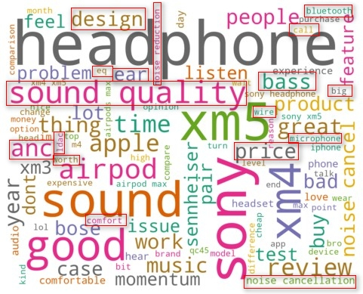

**Figure 15: Wordcloud visualization highlighting features**

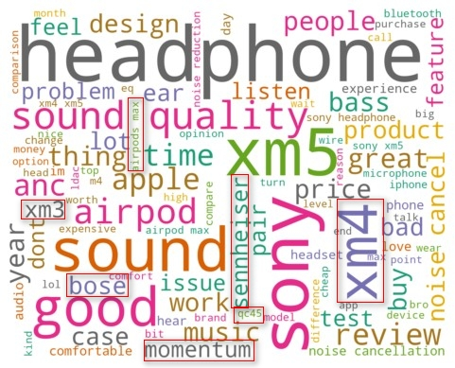

**Figure 16: Wordcloud visualization highlighting models**

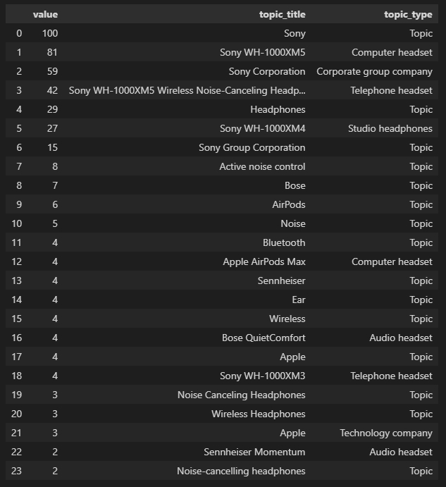

**Figure 17: Google search interest by topic**

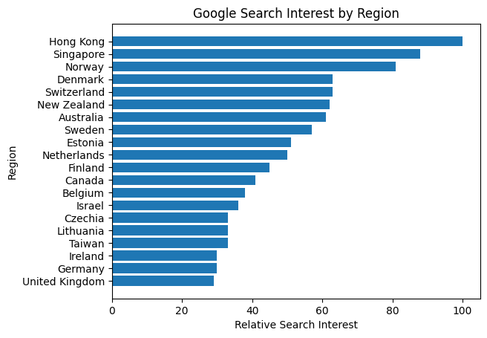

**Figure 18: Google search interest by geographical region**

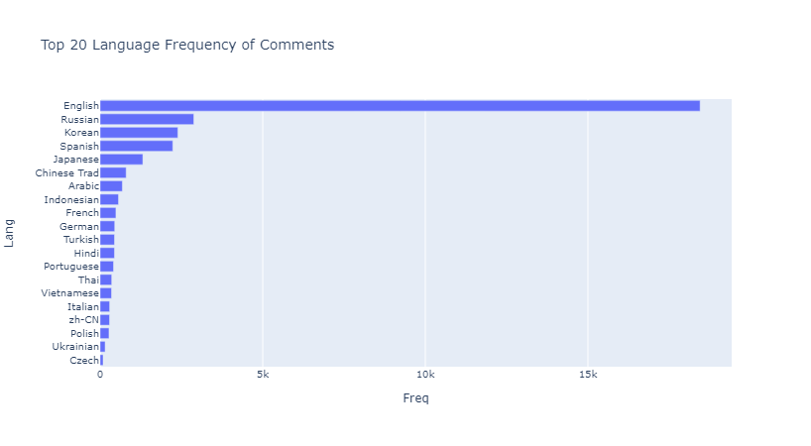

**Figure 19: Top 20 Language Frequency of comments**

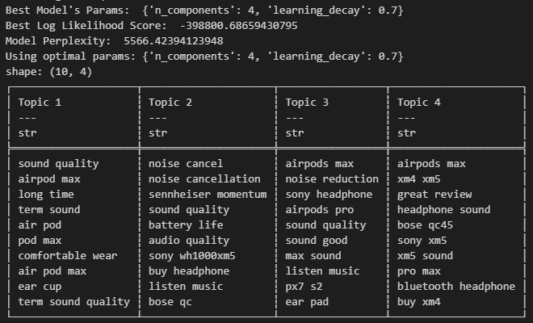

**Figure 20: Initial Topic Modeling 2-grams to 5-grams**

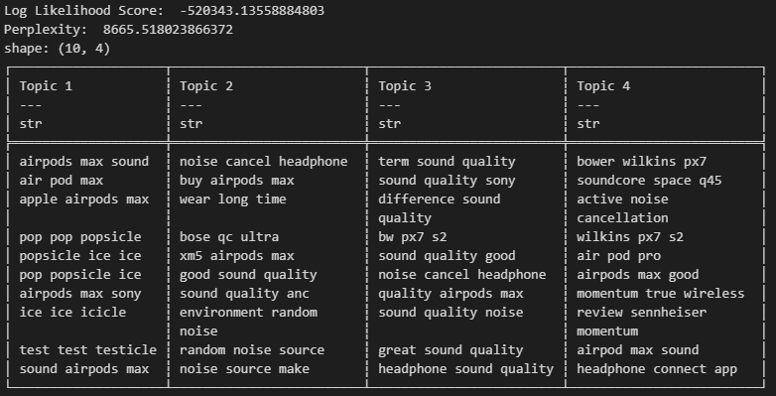

**Figure 21: Refined Topic Modeling 3-grams**

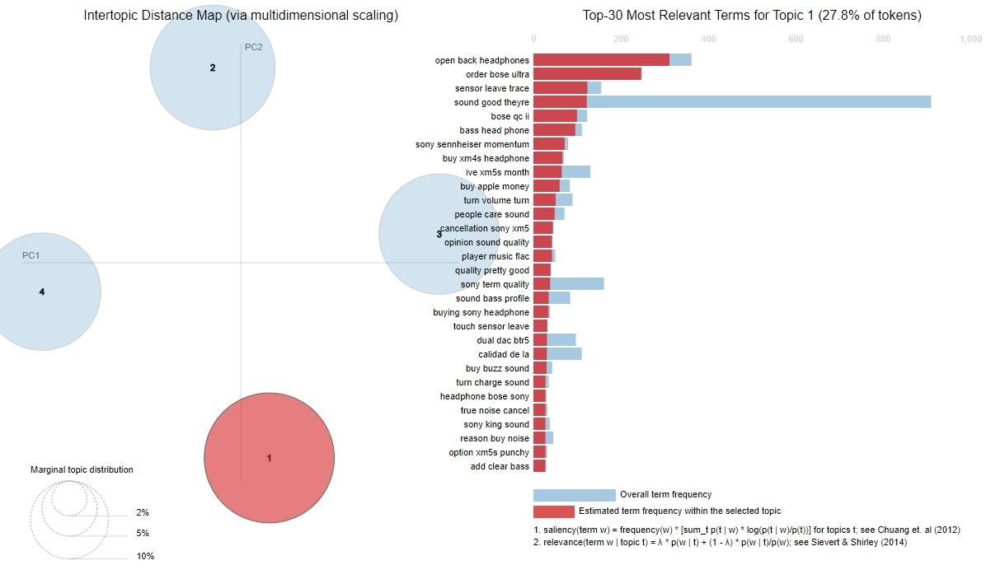

**Figure 22: Topic Modeling Topic 1**

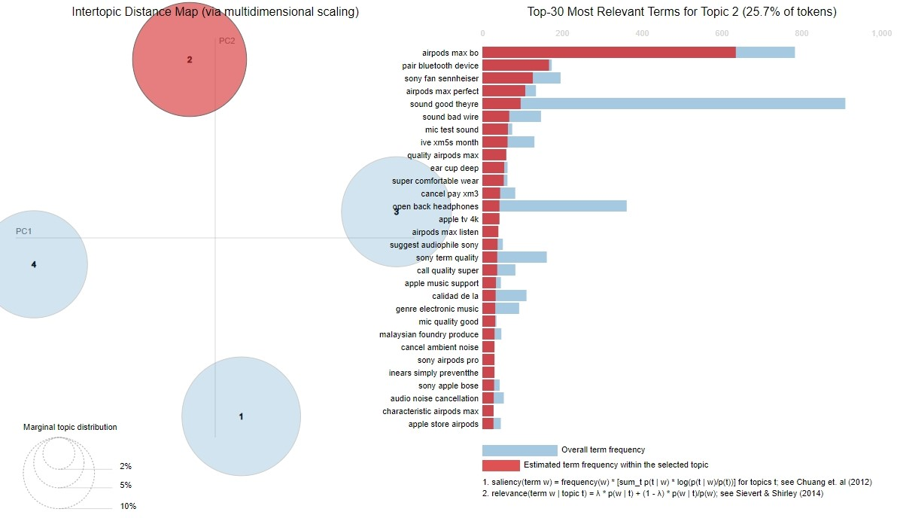

**Figure 23: Topic Modeling Topic 2**

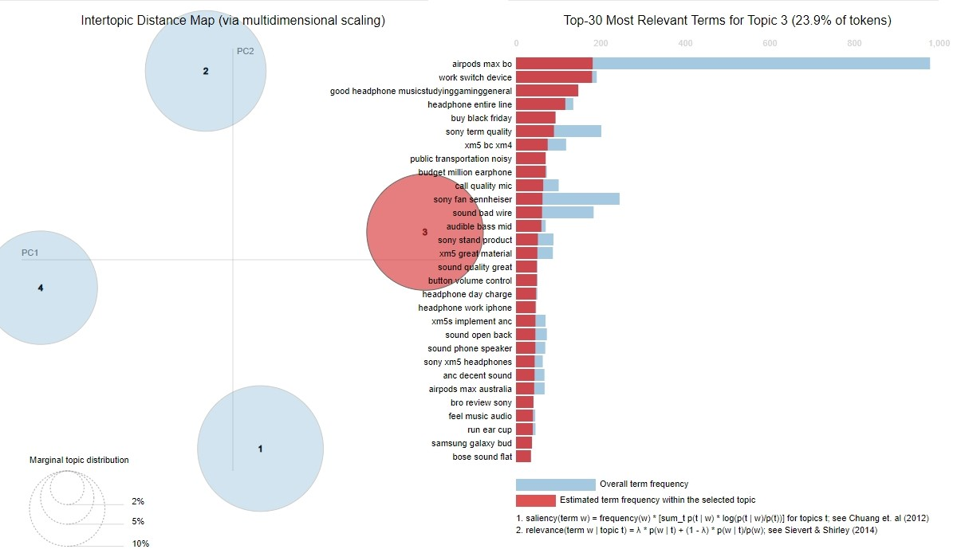

**Figure 24: Topic Modeling Topic 3**

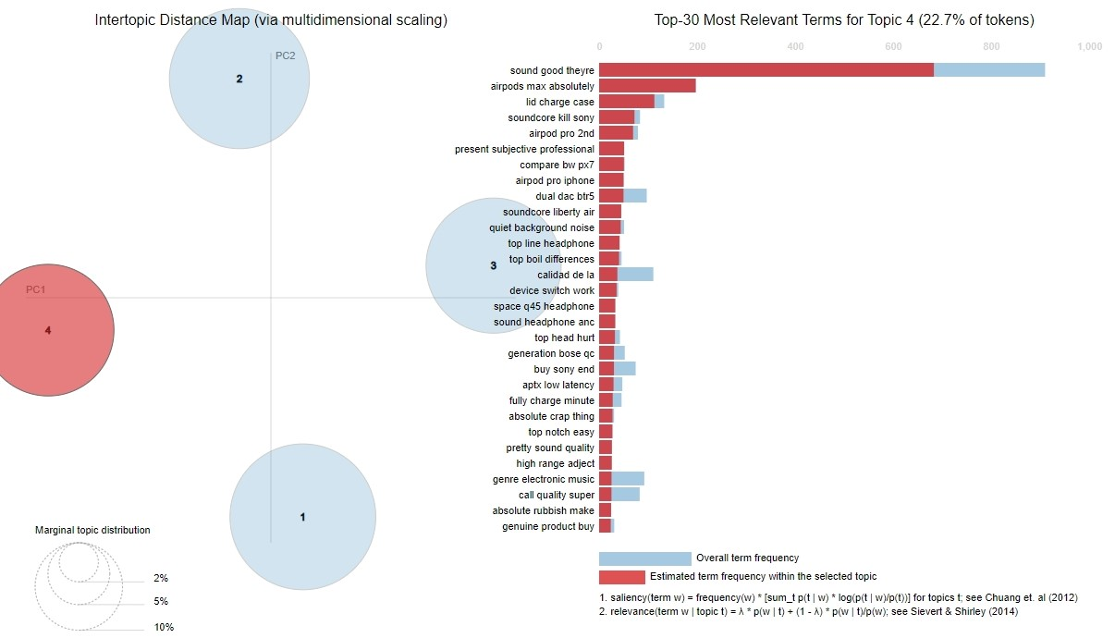

**Figure 25:Topic Modeling Topic 4**

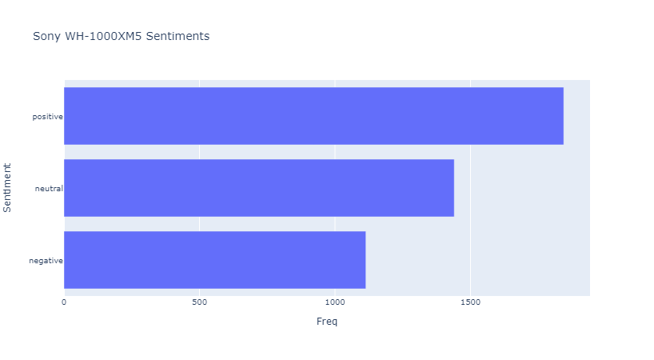

**Figure 26: Sentiment Analysis**

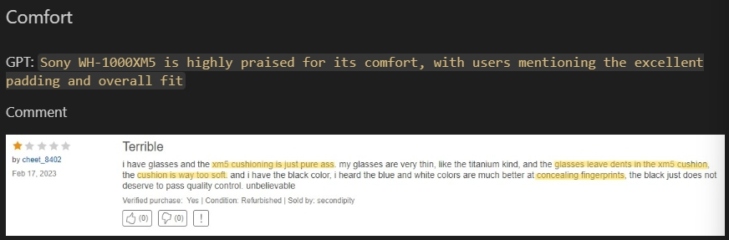

**Figure 27: Comfort**

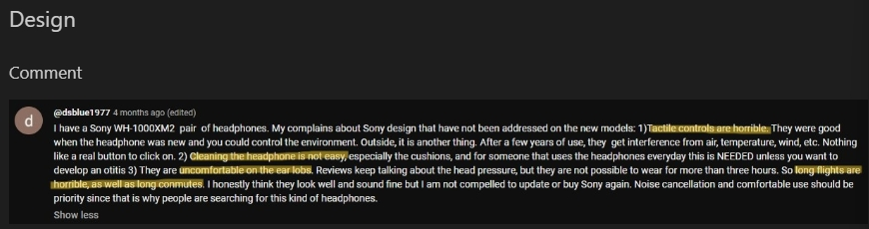

**Figure 28: Design**

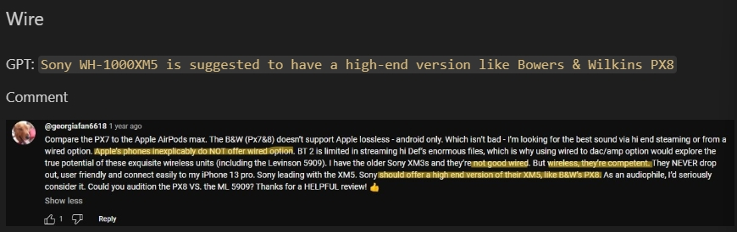

**Figure 29: Wire**

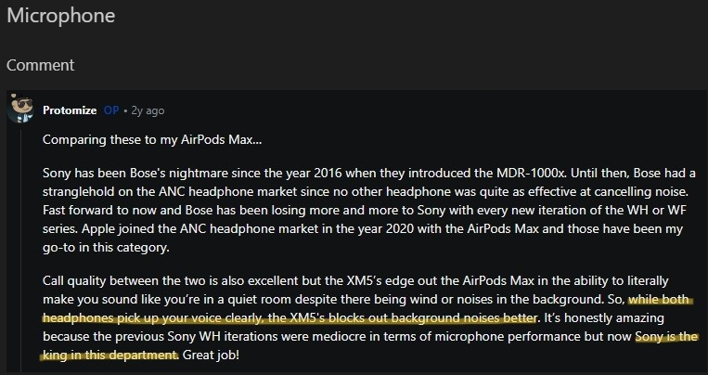

**Figure 30: Microphone**

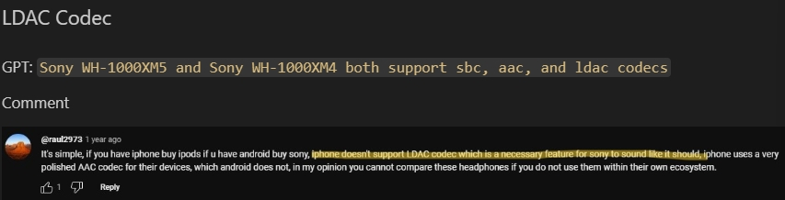

**Figure 31: LDAC codec**

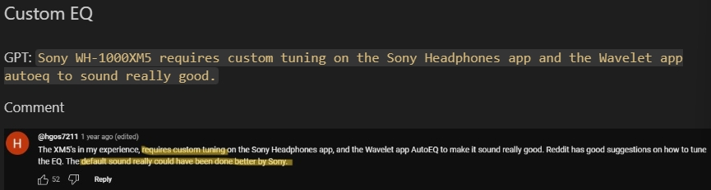

**Figure 32: Custom EQ**

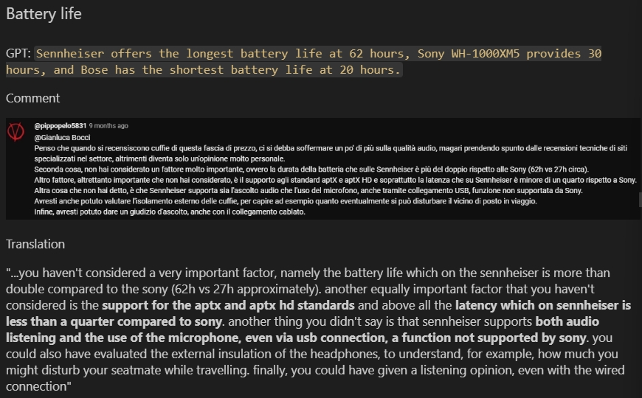

**Figure 33: Battery Life**

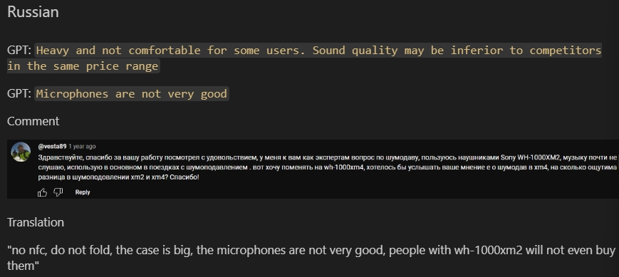

**Figure 34: Russian**

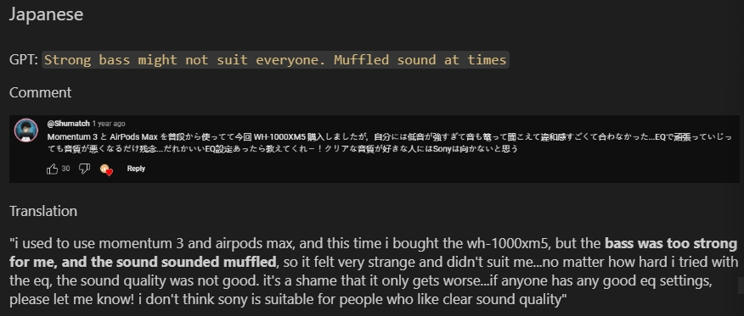

**Figure 35: Japanese 1**

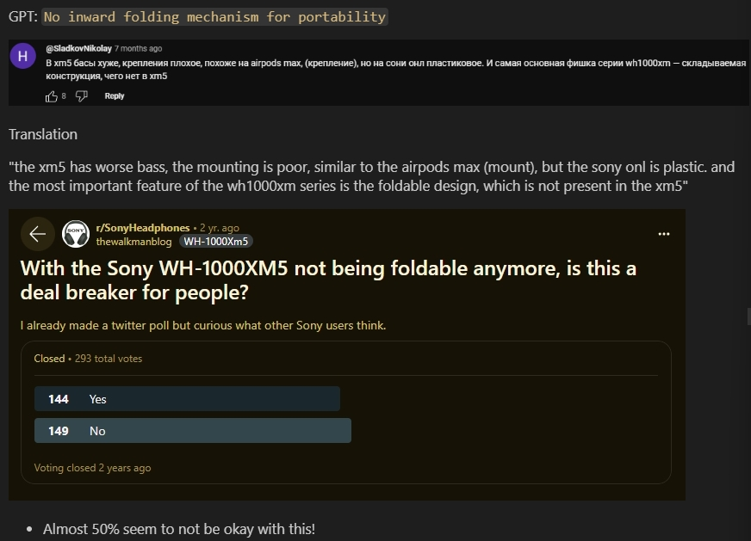

**Figure 36: Japanese 2**

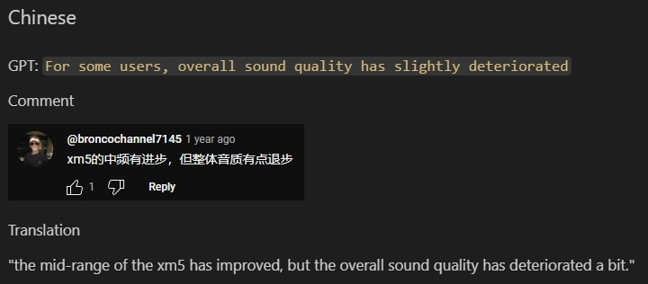

**Figure 37: Mandarin 1**

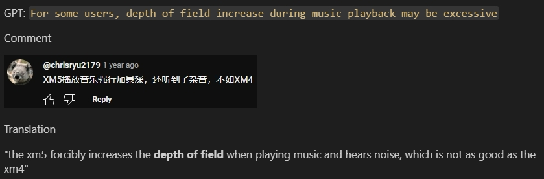

**Figure 38: Mandarin 2**

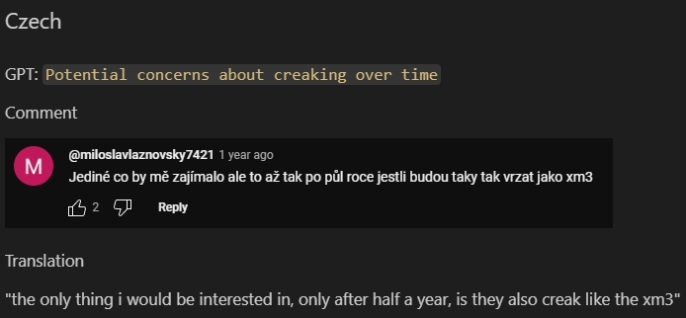

**Figure 39: Czech**

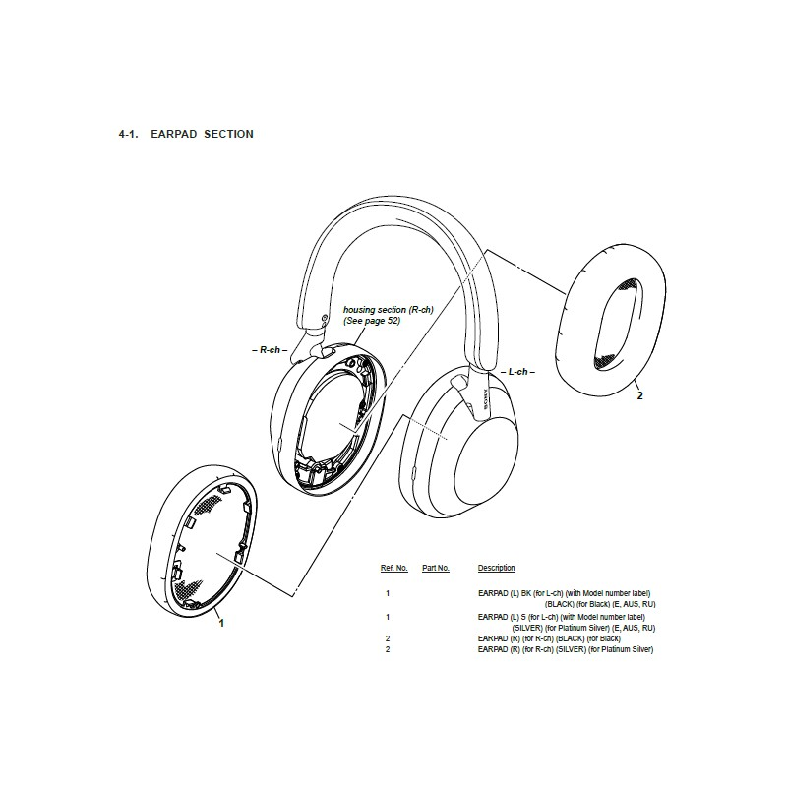

**Figure 40: Exploded Diagram 1**

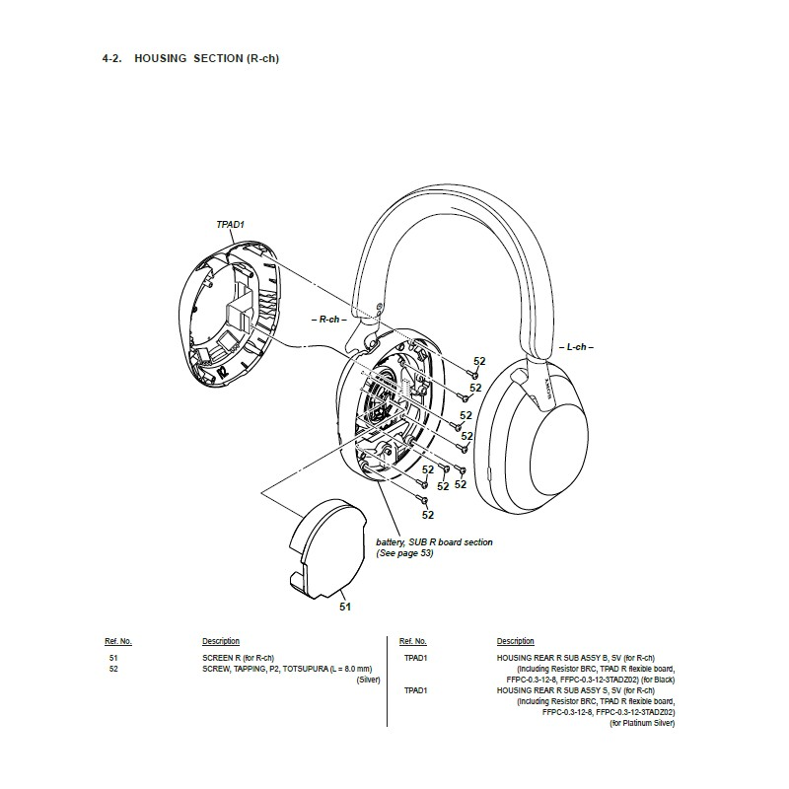

**Figure 41: Exploded Diagram 2**

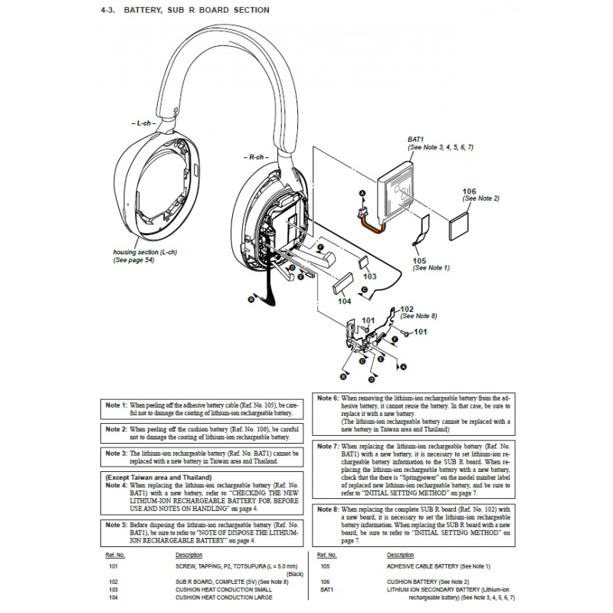

**Figure 42: Exploded Diagram 3**

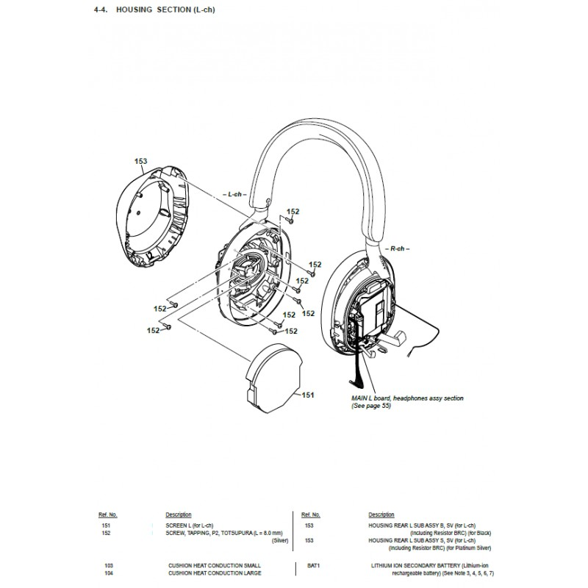

**Figure 43: Exploded Diagram 4**



**Figure 44: Image of product 1**



**Figure 45: Image of product 2**



**Figure 46: Image of product 3**



**Figure 47: Image of product 4**

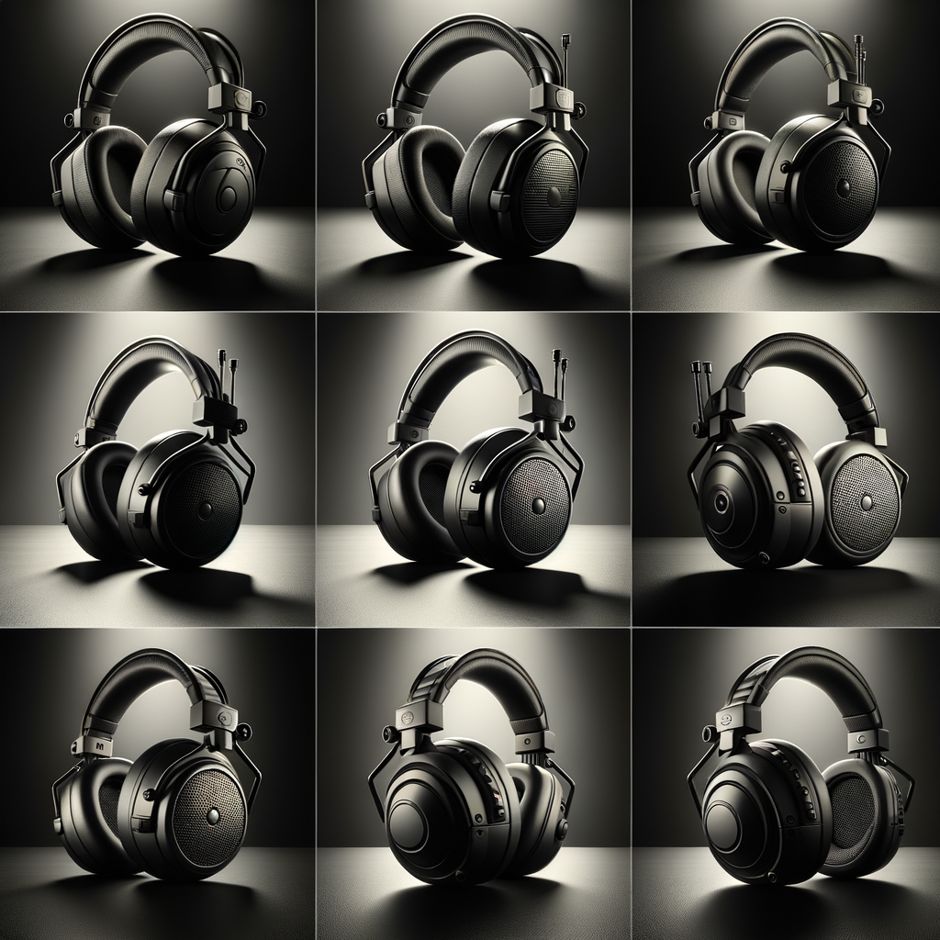

**Figure 48: Image of product 5**



**Figure 49: Image of product usage 1**



**Figure 50: Image of product usage 2**

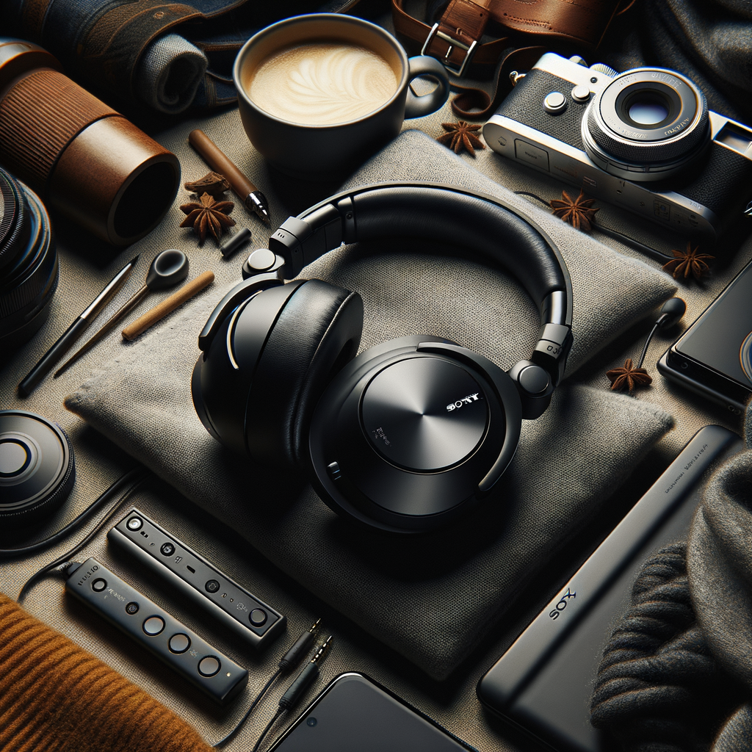

**Figure 51: Image of product usage 3**



**Figure 52: Image of product usage 4**



**Figure 53: Image of product usage 5**

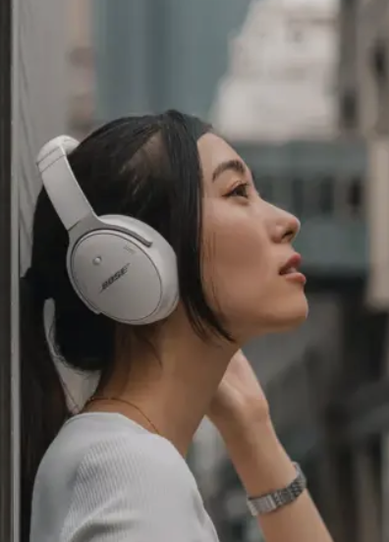

**Figure 54: Reference image of product usage for Dall-E Party**



**Figure 55: Iterated Image of product usage 1**



**Figure 56: Iterated Image of product usage 2**



**Figure 57: Iterated Image of product usage 3**



**Figure 58: Iterated Image of product usage 4**



**Figure 59: Iterated Image of product usage 5**

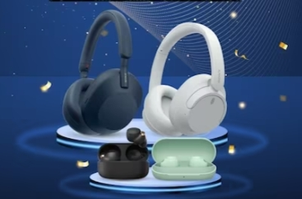

**Figure 60: Sony Image of product 1**

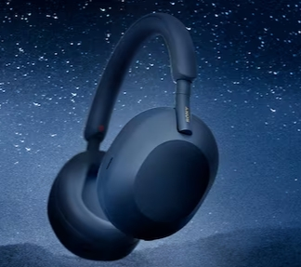

**Figure 61: Sony Image of product 2**



**Figure 62: Sony Image of product usage 1**

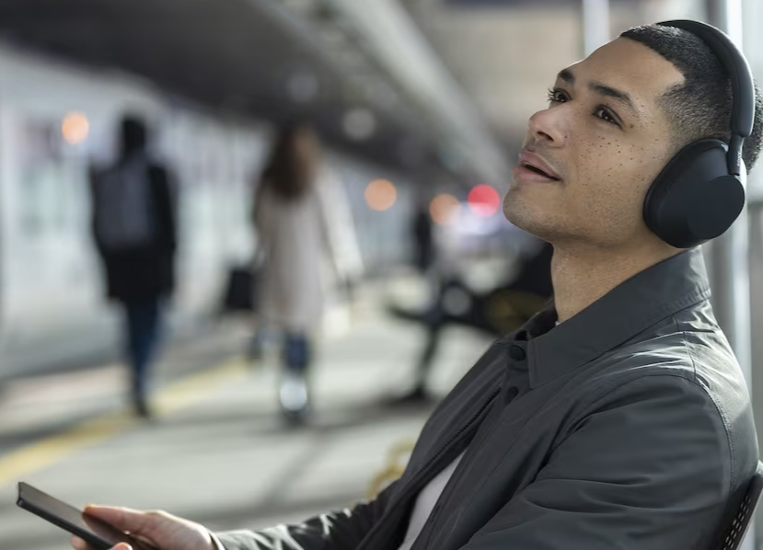

**Figure 63: Sony Image of product usage 2**



**Figure 64: Sony Image of product usage 3**

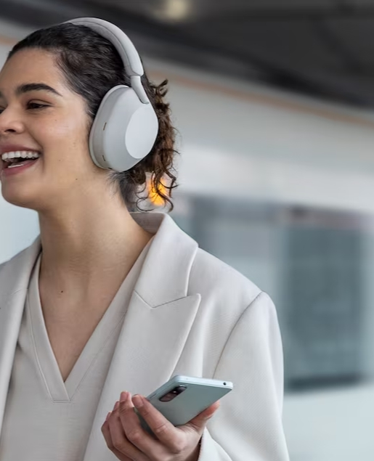

**Figure 65: Sony Image of product usage 4**

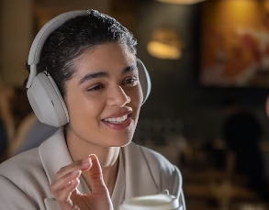

**Figure 66: Sony Image of product usage 5**

1. <https://www.sony.com.sg/electronics/headband-headphones/wh-1000xm5>
2. <https://businessdesk.co.nz/article/the-life/review-sonys-xm5-headphones-are-excellent>
3. <https://www.emarketer.com/content/gen-z-prefers-tiktok-google-searches>
4. <https://gitnux.org/reddit-user-statistics/>
5. <https://www.sony.com.sg/electronics/headband-headphones/wh-1000xm5>
6. <https://www.insidermonkey.com/blog/5-most-valuable-e-commerce-companies-in-the-world-2-1107758/?singlepage=1>
7. <https://www.insidermonkey.com/blog/5-most-valuable-e-commerce-companies-in-the-world-2-1107758/?singlepage=1>
8. <https://www.statista.com/statistics/266595/leading-retailers-worldwide-based-on-revenue/>
9. <https://wwd.com/feature/ebay-etsy-mercari-thredup-therealreal-clothing-resale-players-market-1234894315/>
10. <https://www.forbes.com/sites/jenaebarnes/2023/02/03/twitter-ends-its-free-api-heres-who-will-be-affected/>
11. <https://developers.google.com/youtube/v3/docs>
12. <https://github.com/cubernetes/TikTokCommentScraper>
13. <https://www.youtube.com/watch?v=FsQEm2zalWA>
14. <https://praw.readthedocs.io/en/stable/>
15. <https://www.sony.com.sg/electronics/headband-headphones/wh-1000xm5>
16. <https://www.sony.com.sg/electronics/headband-headphones/wh-1000xm5>
17. <https://chromewebstore.google.com/detail/amazon-reviews-scraper/jncfccofhdpofdddbkacpnbhlfnpbgpa?pli=1>
18. <https://stackoverflow.com/a/16688027/16760208>
19. <https://pypi.org/project/clean-text/>
20. <https://pypi.org/project/googletrans/>
21. <https://pypi.org/project/deep-translator/>
22. <https://huggingface.co/MoritzLaurer/mDeBERTa-v3-base-xnli-multilingual-nli-2mil7>
23. <https://pypi.org/project/wordcloud/>
24. <https://en.wikipedia.org/wiki/List_of_languages_by_number_of_native_speakers>
25. <https://huggingface.co/cardiffnlp/twitter-roberta-base-sentiment-latest>
26. PRODUCT: hereafter will refer to the XM5
27. <https://www.speedyspares.com/shop/sony-manuals/5249-wh-1000xm5-sony-audio-exploded-diagram.html?search_query=WH1000XM5&results=9>
28. <https://brianlovin.com/hn/38432486>
29. <https://techcrunch.com/2009/08/07/translation-party-tapping-into-google-translates-untold-creative-genius/>